**Aws Challenges**

* Launch one **EC2 instance** using **Amazon Linux 2**
* Launched one Ec2 instance

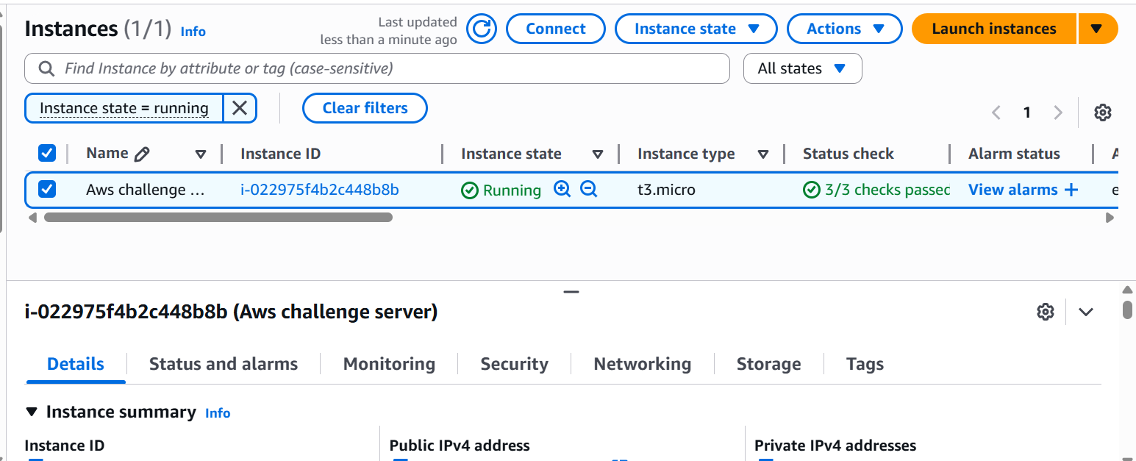

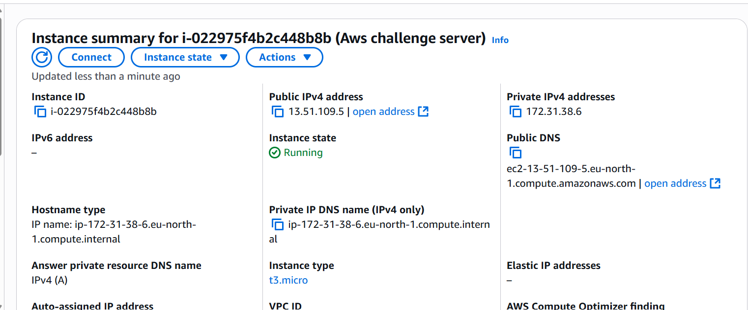

* Install **Docker**
* Connect to Ec2 using **ssh –i security_key.pem ec2-user@public_ip**

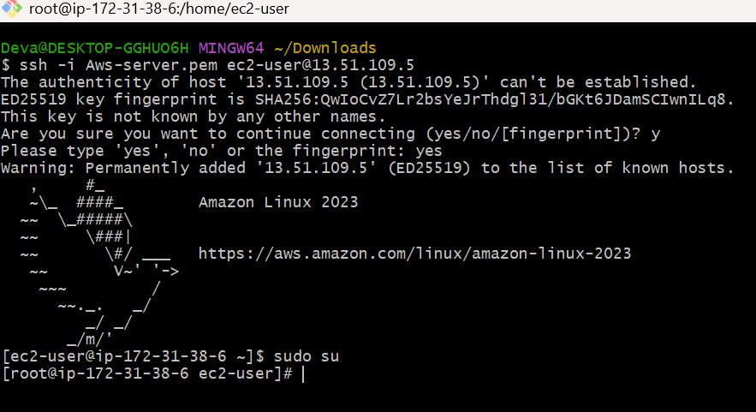

* Run the following commands to install docker
* **Sudo su -**
* **Sudo yum update –y**



* **Sudo yum install docker –y**

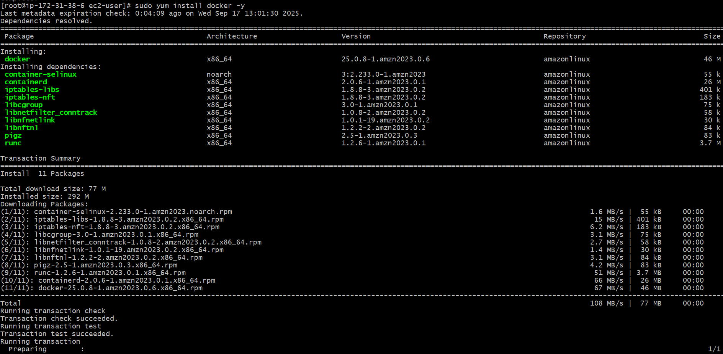

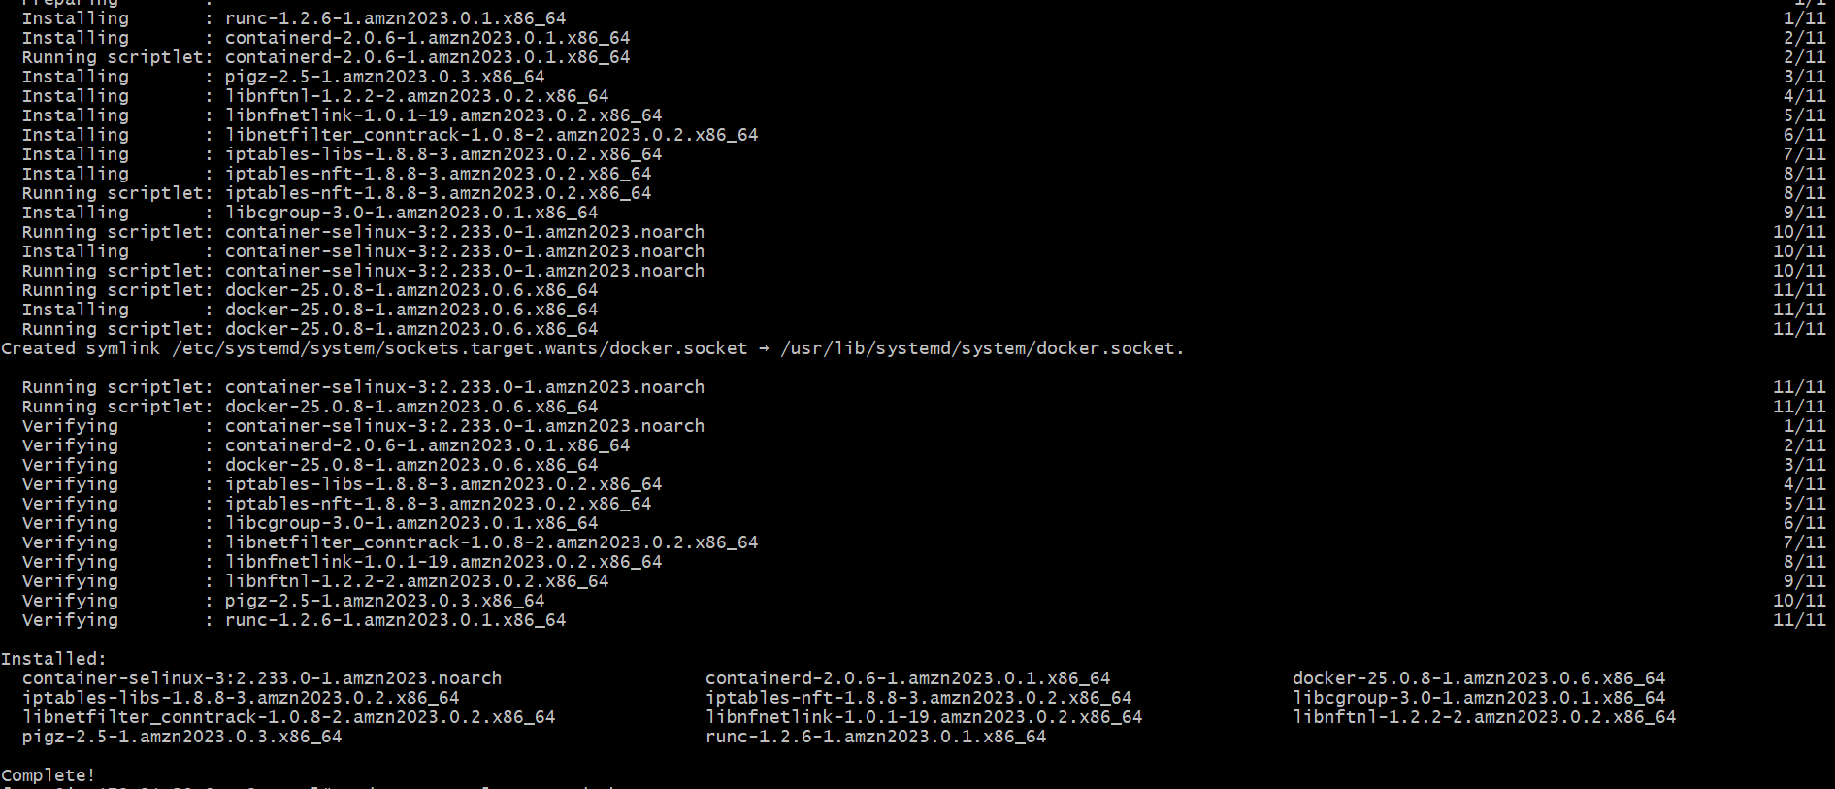

* **Sudo systemctl status docker**
* **Sudo systemctl start docker**
* **Sudo systemctl enable docker**

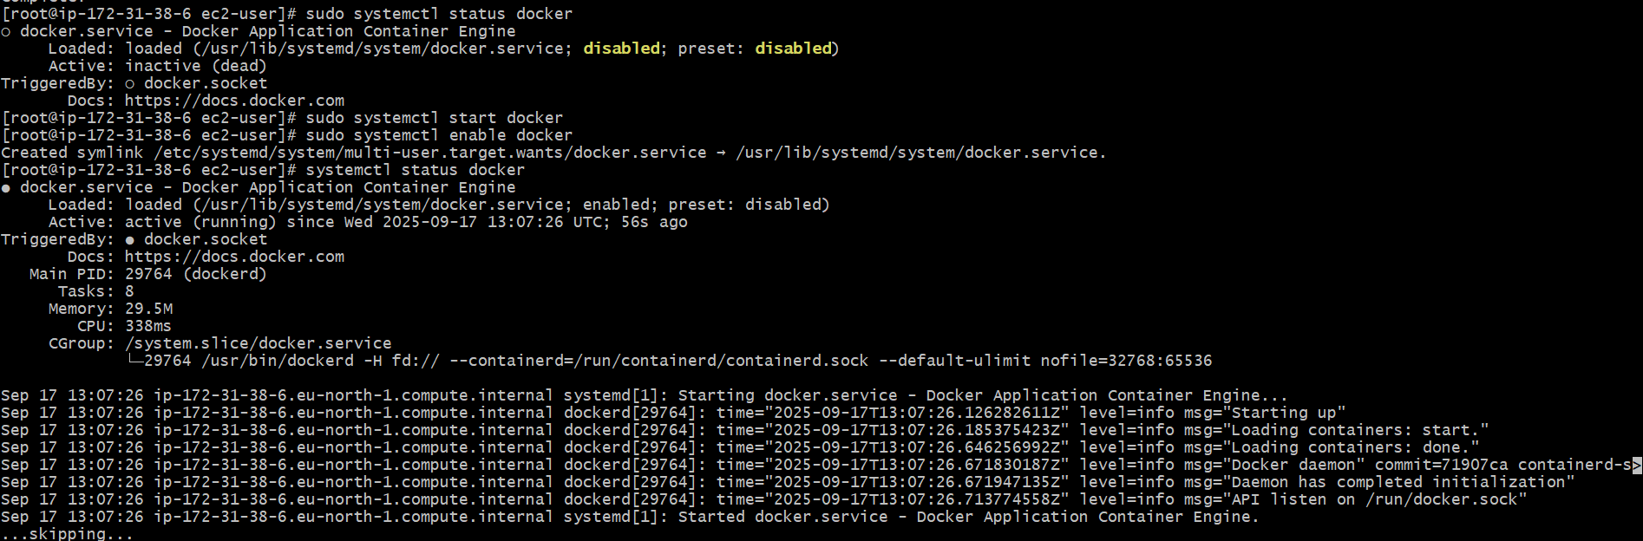

* **Docker info**

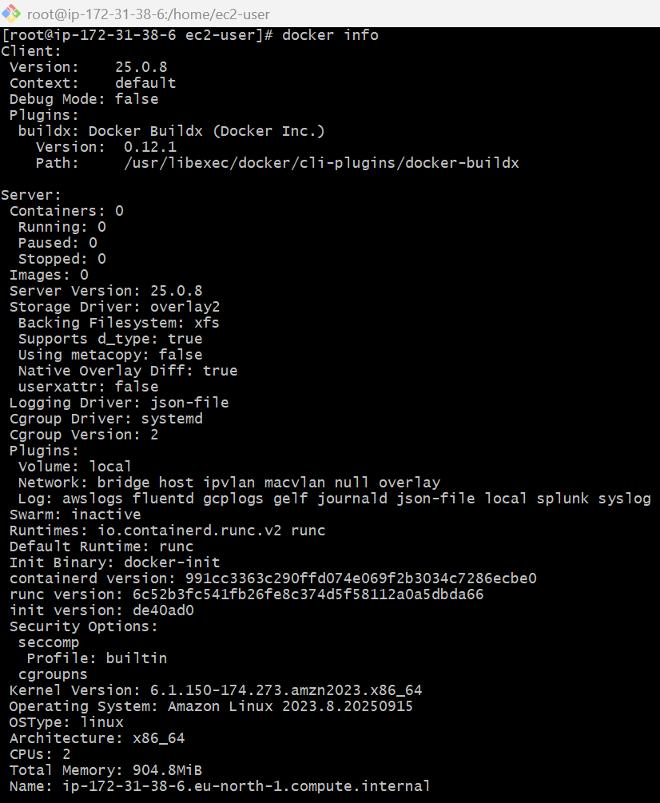

* Install **Jenkins**
* Sudo yum update
* sudo wget -O /etc/yum.repos.d/jenkins.repo \

https://pkg.jenkins.io/redhat/jenkins.rep

* sudo rpm --import <https://pkg.jenkins.io/redhat-stable/jenkins.io-2023.key>
* sudo yum upgrade
* sudo yum install jenkins

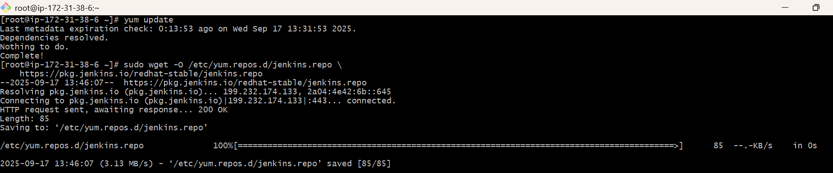

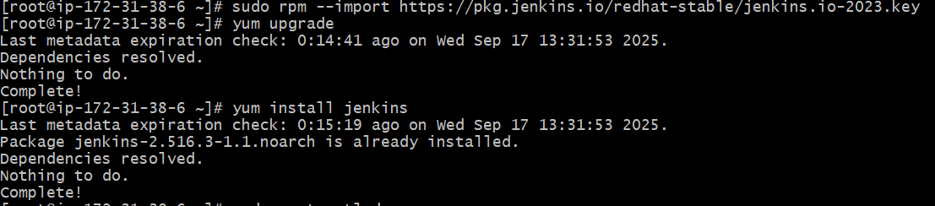

* sudo systemctl enable Jenkins
* sudo systemctl start Jenkins
* sudo systemctl status Jenkins

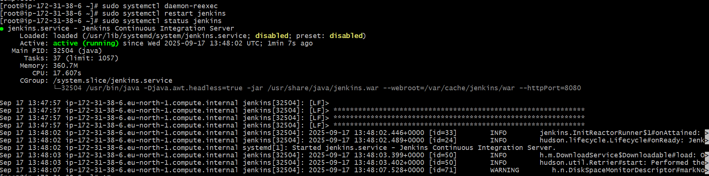

* Run **public_ip:8080** in your browser and copy the path and given **cat path** to get the password copy that password and use it in login page.

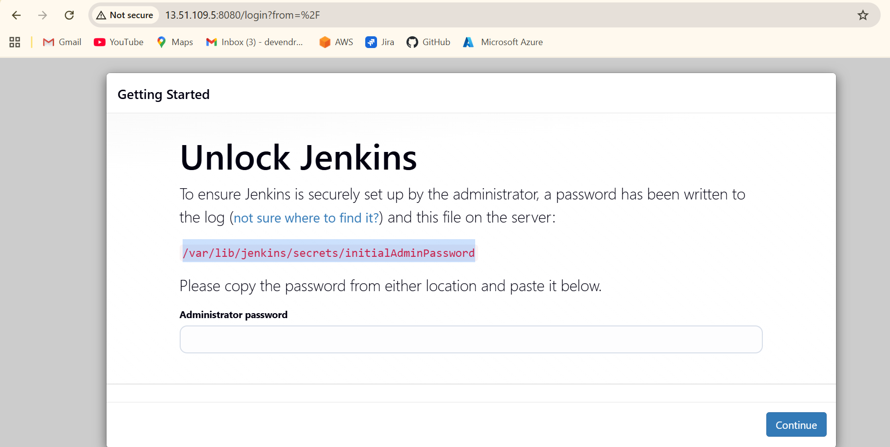



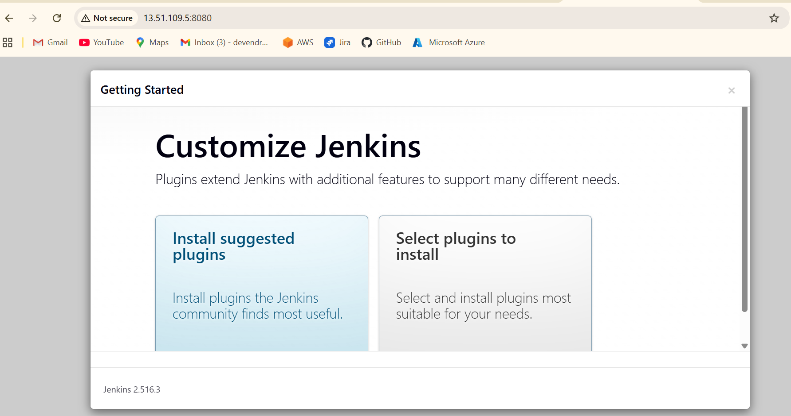

* Click install suggested plugins

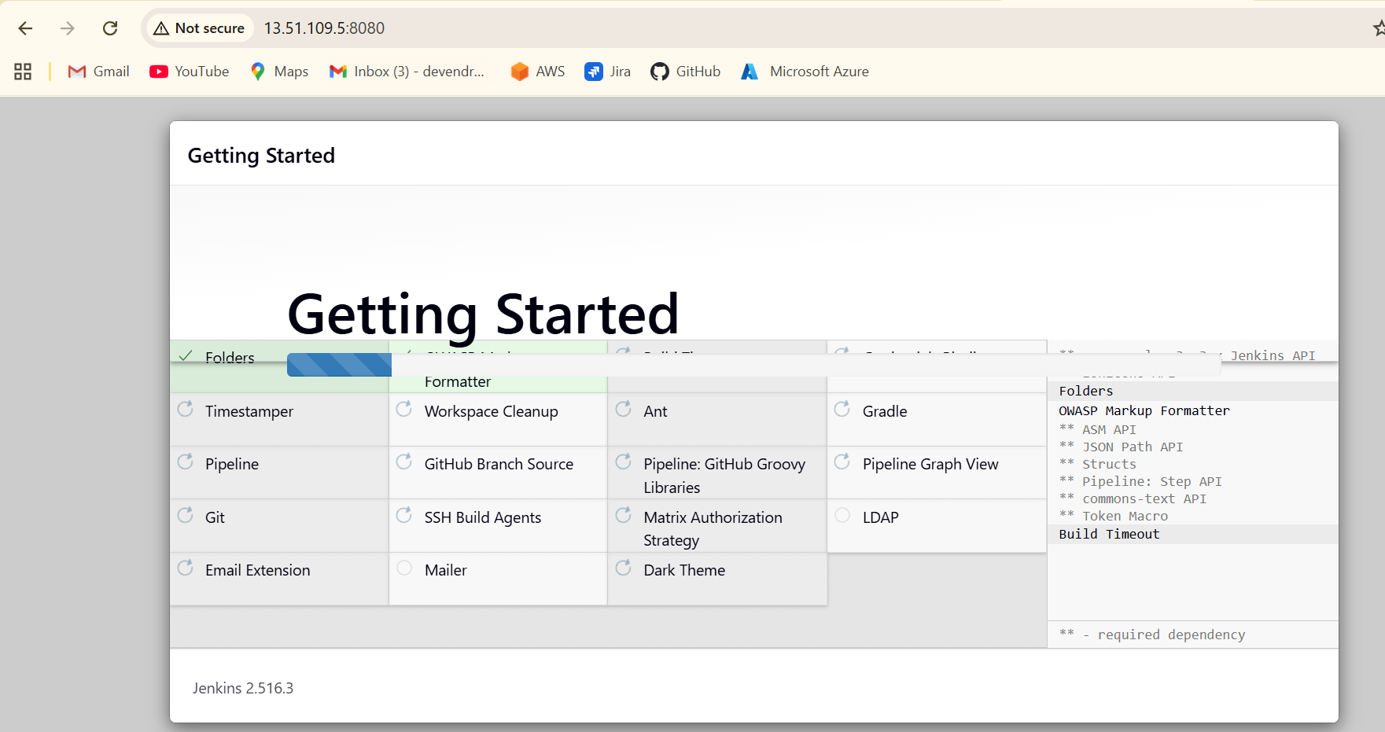

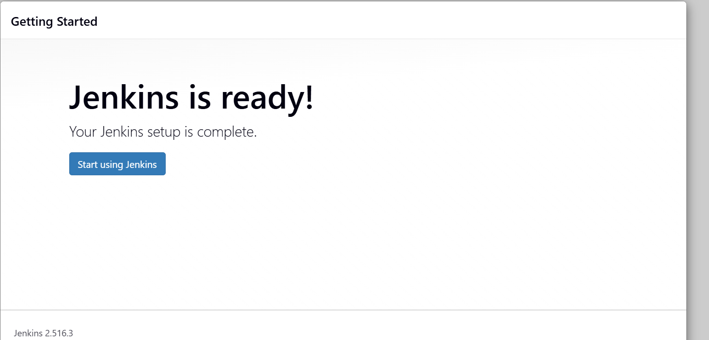

* Select start using jenkins

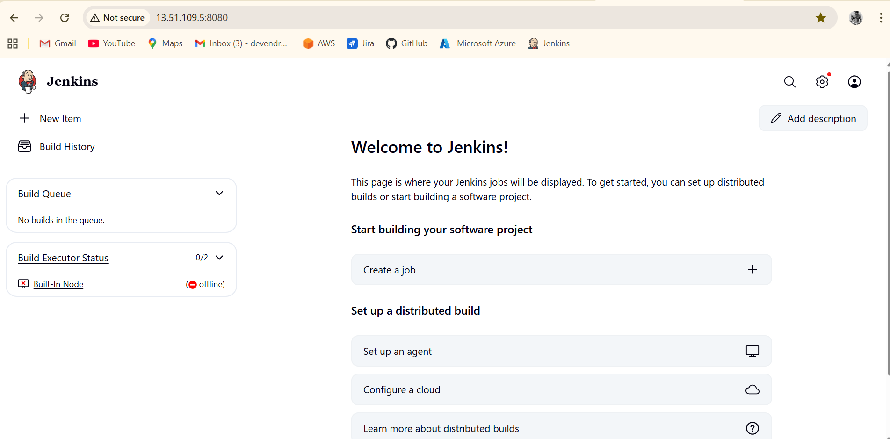

* Install **Apache**
  + Run following commands to install and run HTTPD
  + **Sudo yum install httpd -y**
  + **sudo systemctl start httpd**
  + **sudo systemctl enable httpd**
  + **sudo systemctl status httpd**

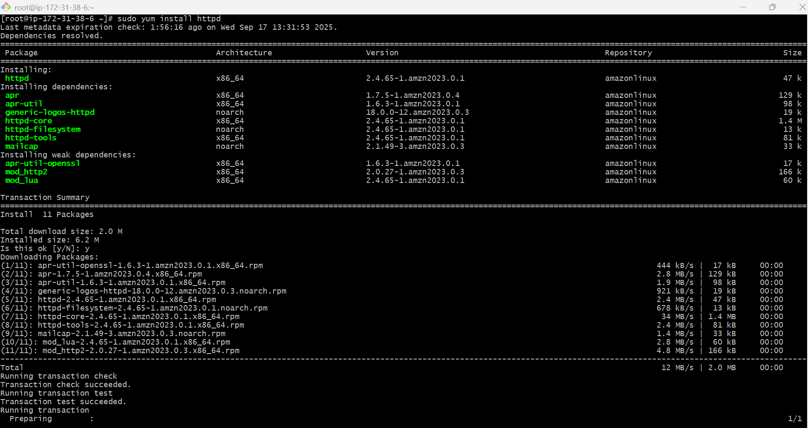

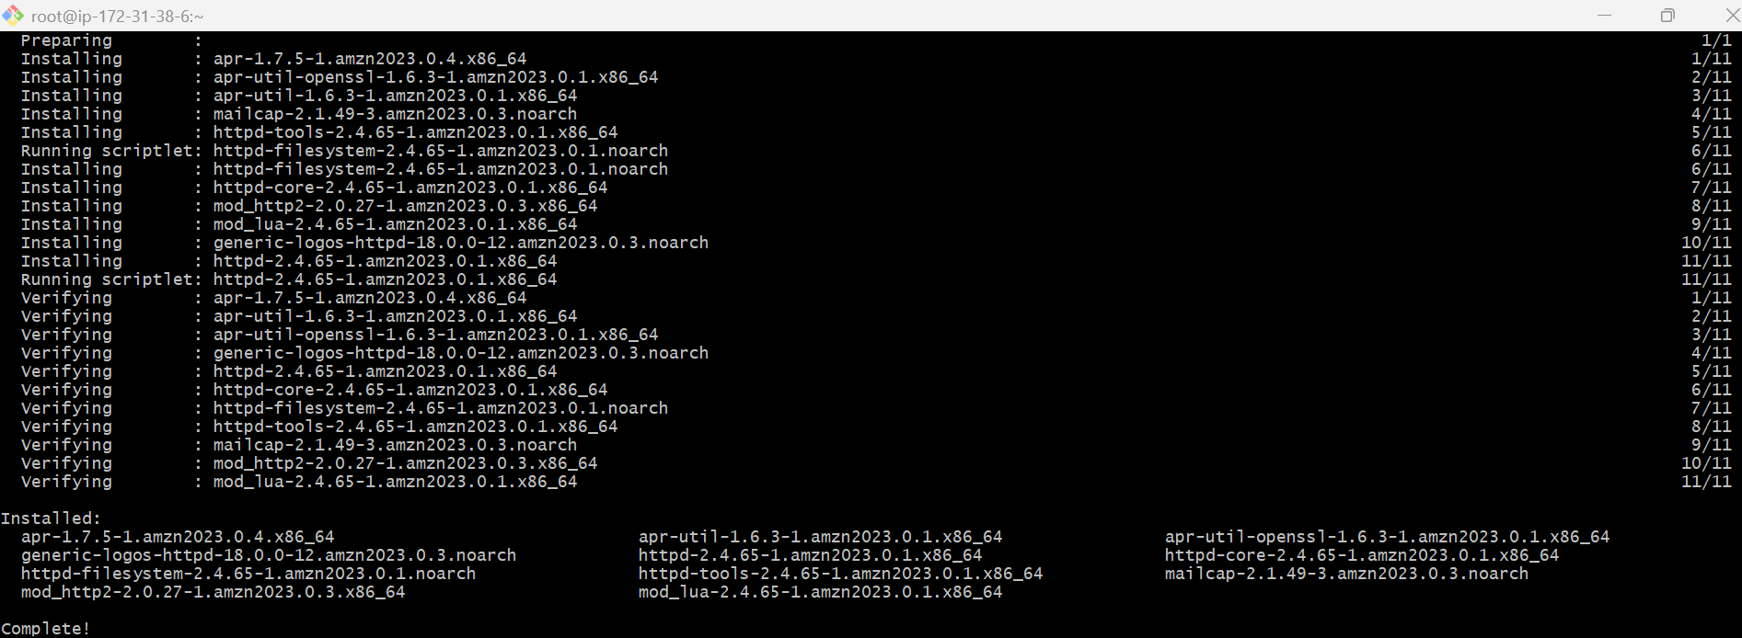

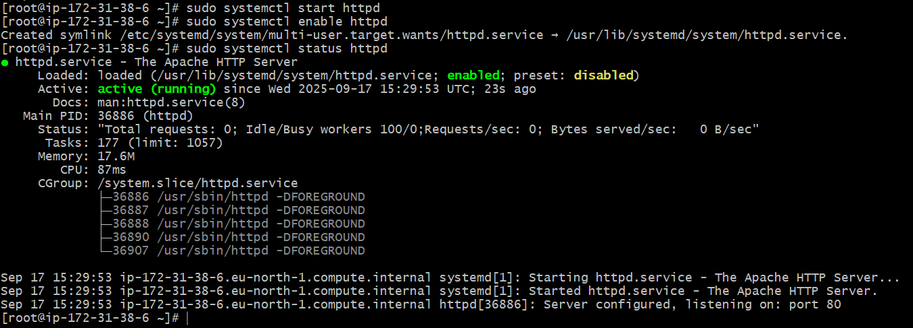

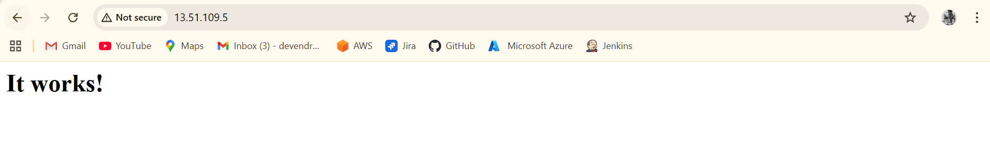

* Install **Nginx**
  + Run the following commands to install and run nginx
  + Sudo yum install nginx –y
  + Sudo systemctl daemon-reload
  + Sudo systemctl restart nginx
  + Sudo systemctl status nginx

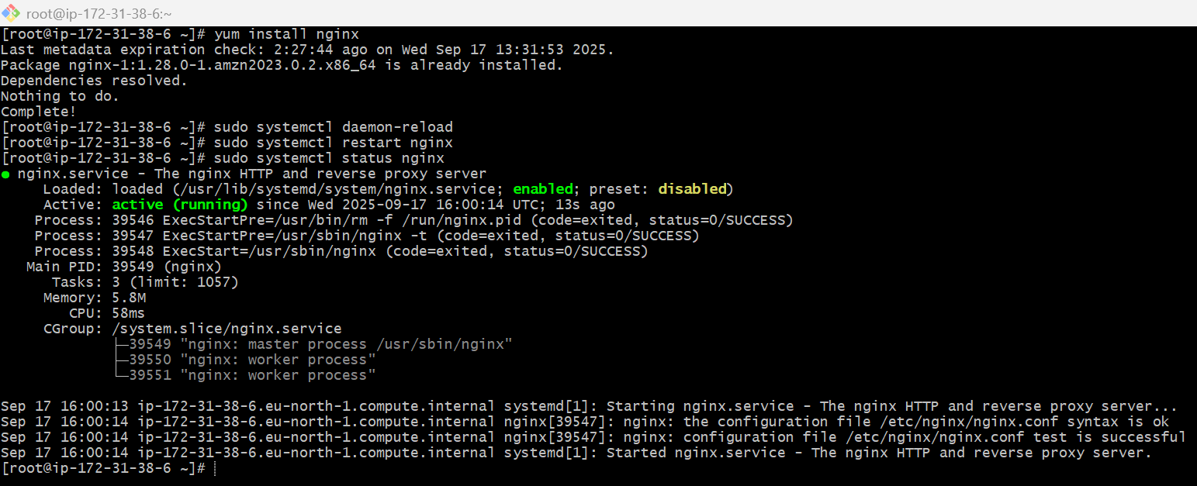

* + Check in browser by using port no 80

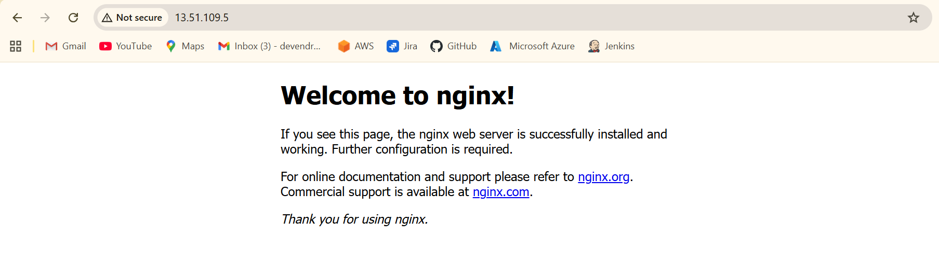

* Install **Apache Tomcat**
  + Move to opt/ directory and run following commands to install Apache Tomcat.
  + Check java –version

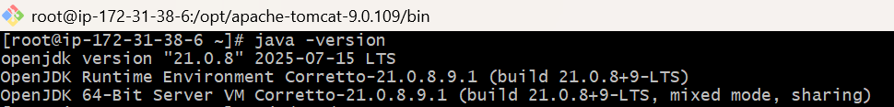

* + Change the directory to /opt/
  + Wget <apache tomcat URL>
  + Tar xvzf apache-tomcat-9.0.109.tar.gz

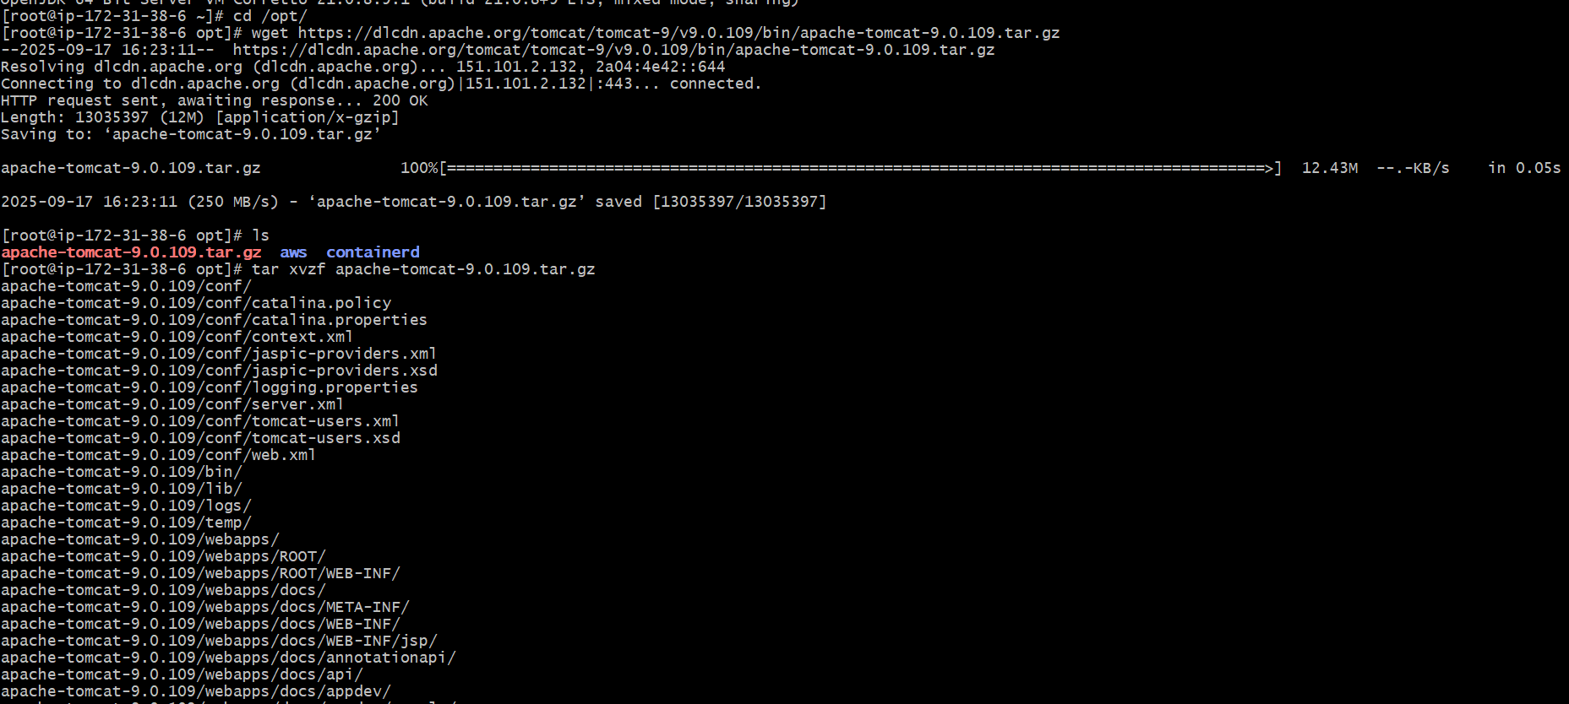

* + Change directory to **apache-tomcat-9.0.109**
  + **Cd bin/**
  + **./startup.sh**

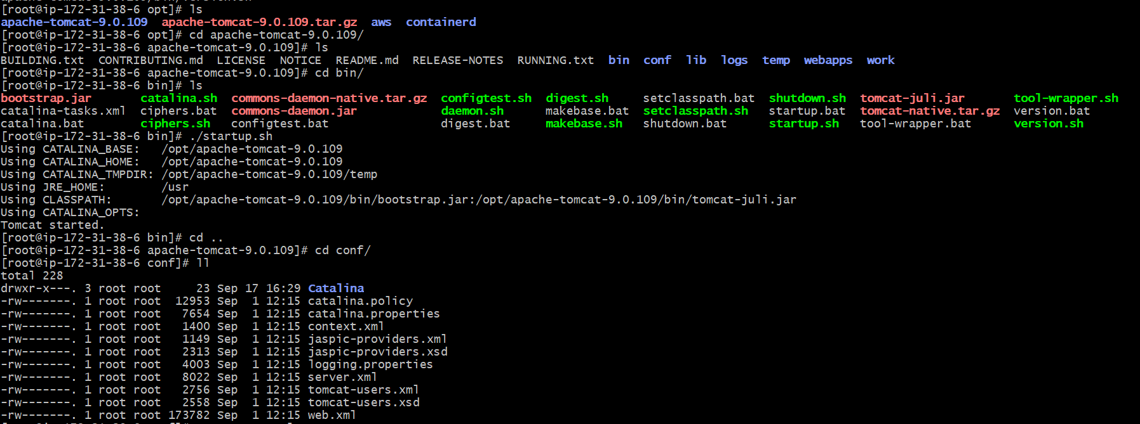

* + Cat server.xml
  + Shutdown.sh
  + ./startup.sh
  + Vi server.xml and paste it and change the port number to 8083

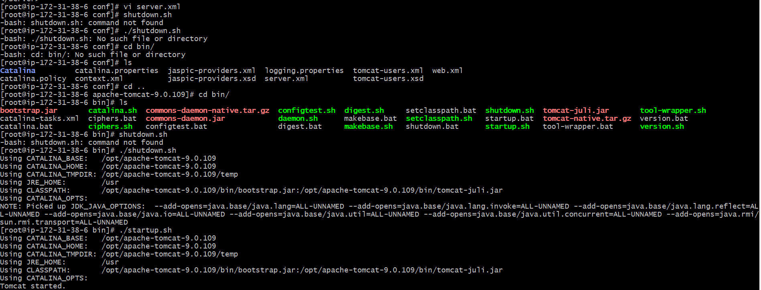

* + Check in browser public ip and port number 8083

